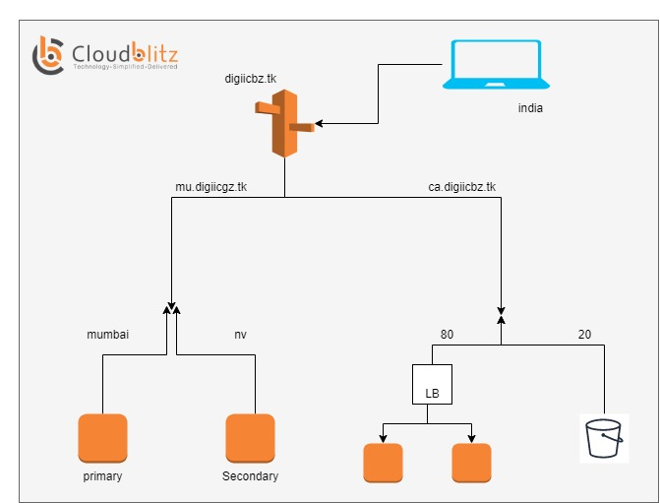
step.1-->create ec2 -instance on North verginia region with hosting website gyme template and create ec2 instnace on mumbai region with hosting
webiste Hangover template then create hosted zone and then gives entry in fenoom register of NS paste an 2 NS then save chage and
with A record gives entry of ip Mumbai Region website in value portion with select ipv4 A record and simply create.
then hit the domain name in browser it will hosted mumbai region i website Hangover.
create health check formumbai region website .
--> then delete (A) record & CNAME Record from hosted zone
CREATE_POLICY
** portion of mu.digizcbz.tk domain **
(failover route policy)
then create policy with name failure policy then -> then connect to failover rule & select heath check->then connect to endpt & select value & IP of M.R. then automatic select of secondary -->then select value & IP of N.R.
---> then create policy and record name with provide subdomain as mu.domain at a time then it give A record values
--> then run cmd thorugh cli on mumbai region instance --> systemctl stop httpd and check there status also
--> then hit dns mu.digizcbz.tk on browser it will show North verginia region website automatically.
** protion of ca.digicbz.tk domain **
(weghited policy)
create two ec2 instance with Mumbai region web hosted two different template then create 1 target group for both with http 80 port then create loadbalcer with adding target group
then create s3 bucket with provide name of bucket of domain like ca.digicbz.tk give full public access and host static website .
- Then create weighted policy
-->then create policy with name weightend policy then -> then connect to wegihtened rule=80 & select heath check->then connect to endpt &
- select application loadbalcer select loadbalcer state and loadbalancer
secondary then connect to wegihtened rule=20 -->then select endpoint as an s3 bucket
bucket name will automatically access s3 bucket name of Mumbai region
- ---> then create policy and record name with provide subdomain as ca.digicbz.tk at a time then it give A record values.
--> then run cmd thorugh cli on mumbai region instance --> amazon-linux-extras install epel -y and yum install stress & stress --help)
- increasing cpuutilazition manually) stress --cpu 80 --io 4 --vm 2 --vm-bytes 128M --timeout 1m on both two ec2-instance in which attach to the loadbalcer .. and increase load or traffic.
- then hit dns on browser ca.digicbz.tk it will show s3 bucket website will eaisily access.
- So task will successfully complete

